
PRODUCT CODE
DCM-17CT
PRODUCT DESCRIPTION
Astra 17” LCD TV/PC Monitor 240volt AC/12volt DC
NARRATIVE
A very high quality flat panel widescreen LCD with built in TV and PC input. Low power draw makes it suitable for 12 volt applications. This wide view angle, quality panel with excellent specifications has multiple input & output options, which add to the versatility of this model. The scart connector adds the ability to get outputs for additional screens or amplifiers via an optional aftermarket scart connector. VESA compliance allows for the use of a range of aftermarket mounting brackets to suit any application. The DCM-17CT is suitable for cars, trucks, boats, buses and motorhomes.

SPECIFICATIONS
17” Widescreen | Resolution: 1280 X 768 (WXGA)
Aspect Ratio: 15:9 | Contrast Ratio: 600:1 (Typical)
Display Area: 372.48mm (H) X 233.488mm (V) | TV: 75 ohm Beiling Lee socket
PC: 15-Pin D-sub X 1 | Composite: RCA Type X 1
S-VHS: S-Video X 1 | Connectors Input - Scart: Full X 1
Component (Y,Pb, Pr): RCA Type x 1 (1080i & 720p) | Audio Input: 3 (PC*1 AV*1 Component L/R 1)
Speakers (Internal): 2 Speaker System (Stereo) | DVI: DVI-D X 1 (720p)
Support Stereo: A2/NICAM (EU) MTS/SAP (US) | Audio Ouputs: Max.6W (3W x 2 channel)
Connectors Output – Scart: Full X 1 | Audio Output: Headphone X 1
Teletex (EU): 10 Pages | Tilt Angle: +30º ~ -10 º (Front / Rear)
OSD Language: 8 Languages (English, Dutch, French, Italian, Spanich, Japanese) | Stand: VESA compliant removeable desk stand
Regulations: MIC, NRTL, CE, FCC(DOC), VCCI-B, CB | Power Consumption: Operating: 60W, Standy-By, less than 5W
Dimensions Set (WxHxD): 585 x 465 x 200mm | Weight: Net: 6.5Kg, Gross 9Kg
Power Supply: DC 12V/5A

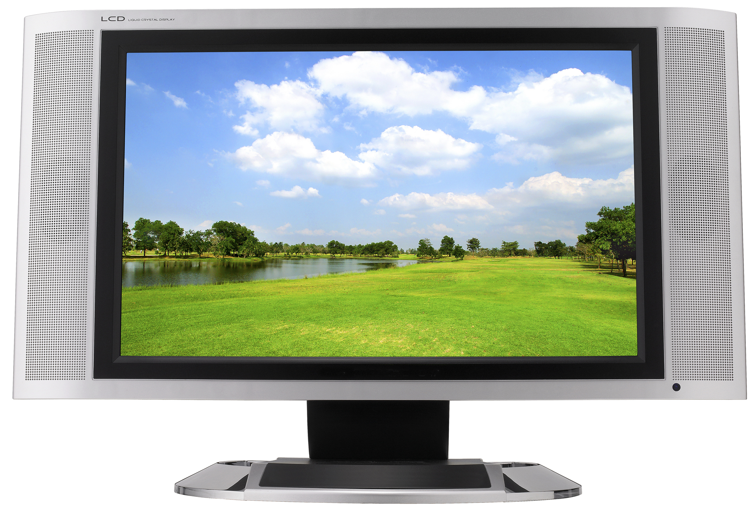
DATE OF PRODUCT RELEASE
May 2007 RRP $899

